/\*\*\*\*\*\*\*\*\*\*\*\*\*\*\*\*\*\*\*\*\*\*\*\*\*\*\*\*\*\*\*\*\*\*\*\*\*\*\*\*\*\*\*

\* Programming excercise 73004 \*

\* Maxwell Stephens \*

\* 12:30 TTh \*

\* 73004, 3/23/17 \*

\*\*\*\*\*\*\*\*\*\*\*\*\*\*\*\*\*\*\*\*\*\*\*\*\*\*\*\*\*\*\*\*\*\*\*\*\*\*\*\*\*\*\*/

/\*

This program calculates the mpg of a car taking in liters and miles traveled

\*/

/\*

Write a program that prompts the user to enter the average rainfall for each

month of the year. Then, prompt the user to enter the actual amount of rainfall

for each month of this year. Finally, print out a table, formatted to be left

justified with a width of 20 spaces for each column, that displays the average

amount of rainfall, the actual amount of rainfall, and the difference between the two

for each month of the year. Your program should use arrays to hold the values for

average monthly rainfall, actual monthly rainfall, and month name .

\*/

#include <iomanip>

#include <iostream>

#include <fstream>

#include <string>

using namespace std;

int main() {

string months[12] =

{ "January", "February", "March", "April",

"May", "June", "July", "August", "September",

"October", "November", "December" };

double averageRainfall[12];

double actualRainfall[12];

for (int i = 0; i < 12; i++) {

cout << "Enter the average monthly rainfall for " << months[i] << " in inches." << endl;

cin >> averageRainfall[i];

}

for (int i = 0; i < 12; i++) {

cout << "Enter this year's actual rainfall for " << months[i] << " in inches." << endl;

cin >> actualRainfall[i];

}

cout << left << setw(15) << "Month" << setw(25) << "Average Rainfall" << setw(30)

<< "This Year's Rainfall" << setw(10) << "Difference" << endl;

for (int i = 0; i < 12; i++) {

cout << left << setw(15) << months[i] << setw(25) << averageRainfall[i] << setw(30)

<< actualRainfall[i] << setw(10) << averageRainfall[i] - actualRainfall[i] << endl;

}

system("pause");

return 0;

}

/\*

SAMPLE OUTPUT:

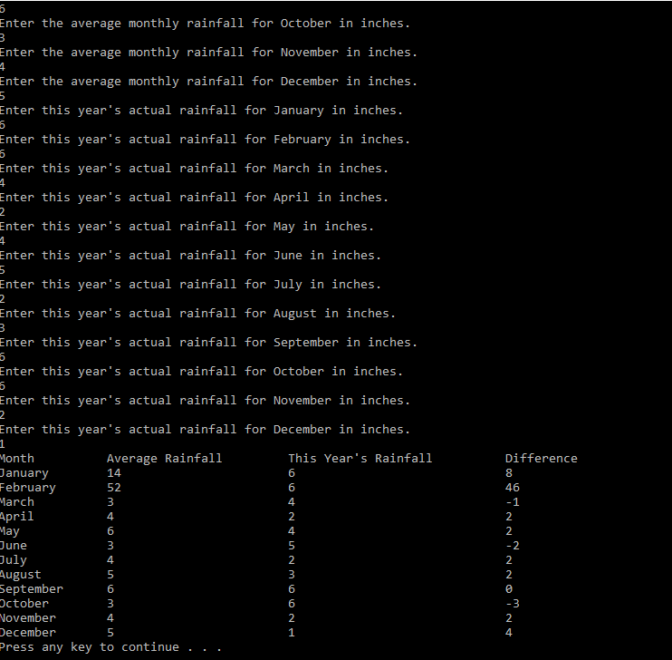

Self-Evaluation:

4: Works perfectly, code properly documented

I believe I earned 4 points.

\*/